

**PROJECT REPORT**

**IT Workshop Lab (18B17CI372)**

**Faculty: Dr. Alok Kumar**

Made By:

Akshit Sharna (211435)

Niharika (211438)

Saksham Singh Salathia (211444)

Aditya Gupta (211230)

**INDEX**

|  |  |  |
| --- | --- | --- |
| **Sr. No.** | **Title** | **Page Range** |
| **1** | Certificate | 3 |
| **2** | Introduction | 4 |
| **3** | Methodology | 4 |
| **4** | Flow Chart | 5 |
| **5** | Source Code | 6 |
| **6** | Outputs | 8 |

**CERTIFICATE**

This is to certify that –

1. Akshit Sharma
2. Niharika
3. Saksham Singh Salathia
4. Aditya Gupta,

students of CS-34 , have successfully completed the IT – Workshop Lab (MATLAB) Project – ‘Measuring diameter of an object within an image’ , using MATLAB under the guidance of Dr. Alok Kumar during the academic session 2022-23 in partial fulfilment of IT Workshop Lab Practical Examination.

_____________________

Dr. Alok Kumar

**INTRODUCTION**

In this project, we use MATLAB (Matrix Laboratory) and its Image Processing Toolbox (and its functions) in order to determine diameter of an object in a given image and give that as output. We chose this project because it is often that we find ourselves in a spot where we need to extract data from an image, be it text, or sometimes, measure something within an image.

**METHODOLOGY**

We start with importing an image to our workspace using the imread function of the image processing toolbox. Then, we segment the image into its RGB segments. We then threshold the blue plane, and remove any noise that is present in the image, and remove any blobs that are smaller than 7 pixels. Then, we measure the object diameter (in pixels) and use the regionprops function of the toolbox, and then show the result on the image.

**OBJECTIVE**

To measure diameter of a given object in an image.

**FLOW CHART**

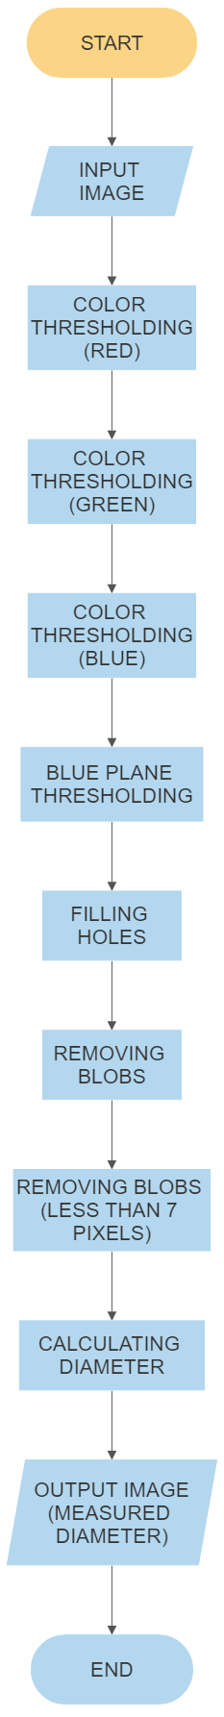

**SOURCE CODE**

|  |
| --- |
| clc;  clear all;  %IMPORTING IMAGE  imported_image=imread('D:\Coding Files\University\2022 ODD SEM\MATLAB\Baseball.jpg');  imshow(imported_image);  %SEGMENT IMAGE  %Dividing image into respective RGB in intenstites  redseg=imported_image(:,:,1);  blueseg=imported_image(:,:,3);  greenseg=imported_image(:,:,2);  figure(1)  subplot(2,2,1);  imshow(imported_image);  title('Original Image');  subplot(2,2,2);  imshow(redseg);  title('Red Plane');  subplot(2,2,3);  imshow(greenseg);  title('Green Plane');  subplot(2,2,4);  imshow(blueseg);  title('Blue Plane');  %threshold blue plane  figure(2)  level=0.37;  bw2=im2bw(blueseg,level);  subplot(2,2,1);  imshow(bw2);  title('Blue threshold');  %NOISE REMOVING  %Filling holes  fill=imfill(bw2,'holes');  subplot(2,2,2);  imshow(fill)  title('No holes');  %Removing blobs on the border of mage  blob=imclearborder(fill);  subplot(2,2,3);  imshow(blob);  title('Blobs removed');  %Removing blobs less than 7 pixel  spb=strel('disk',7);  open=imopen(fill,spb);  subplot(2,2,4);  imshow(open);  title('No small blob');  %OBJECT DIAMETER  dm=regionprops(open,'MajorAxisLength');  %RESULT  figure(3)  imshow(imported_image)  d=imdistline; |

**OUTPUTS**

**Image used as input:**

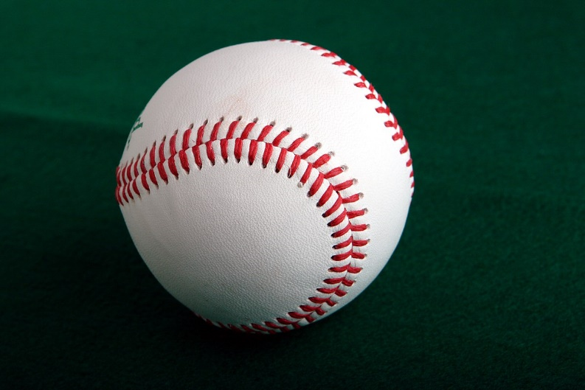

**RGB Segmented Output:**

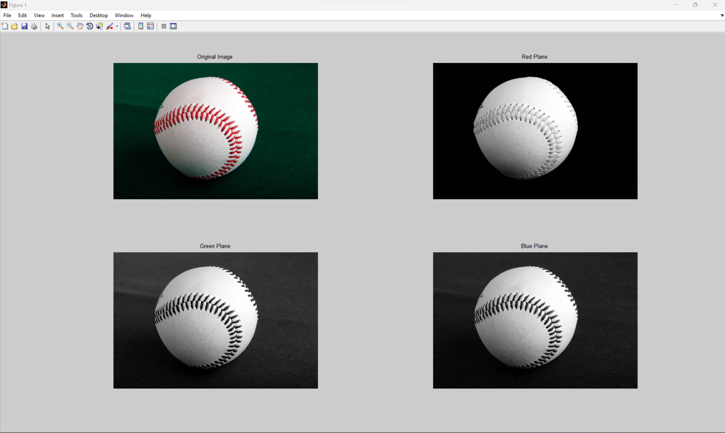

**Removing Noise:**

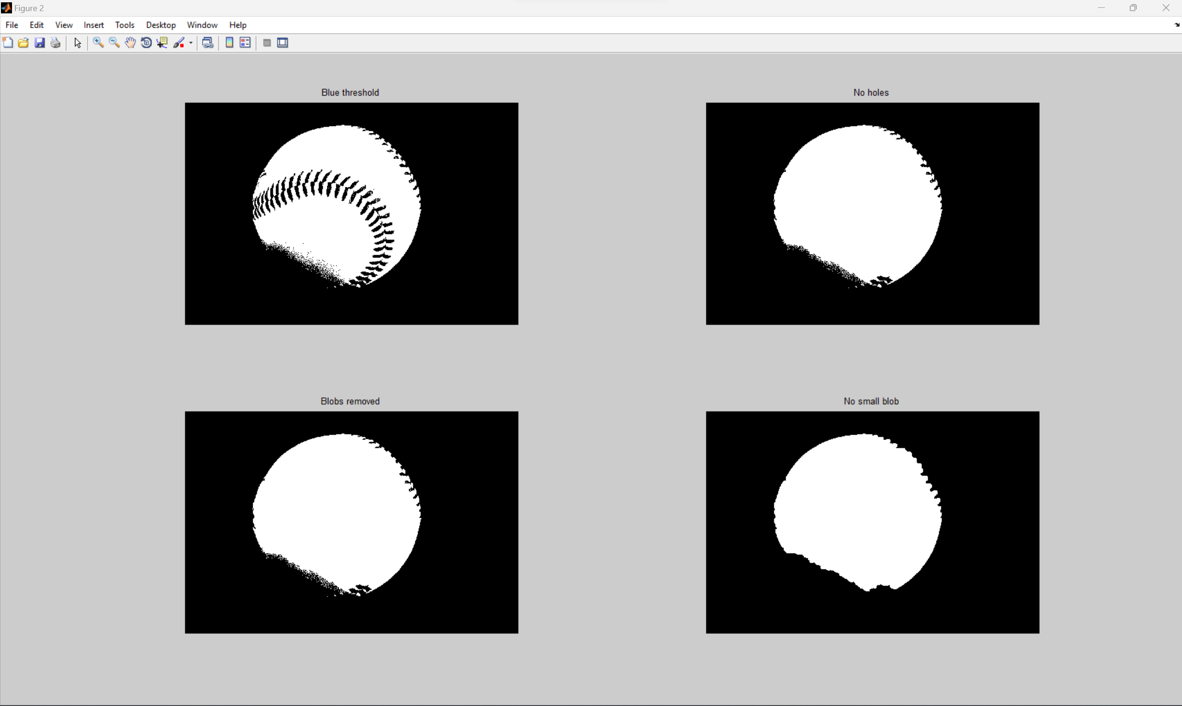

**Final Output:**

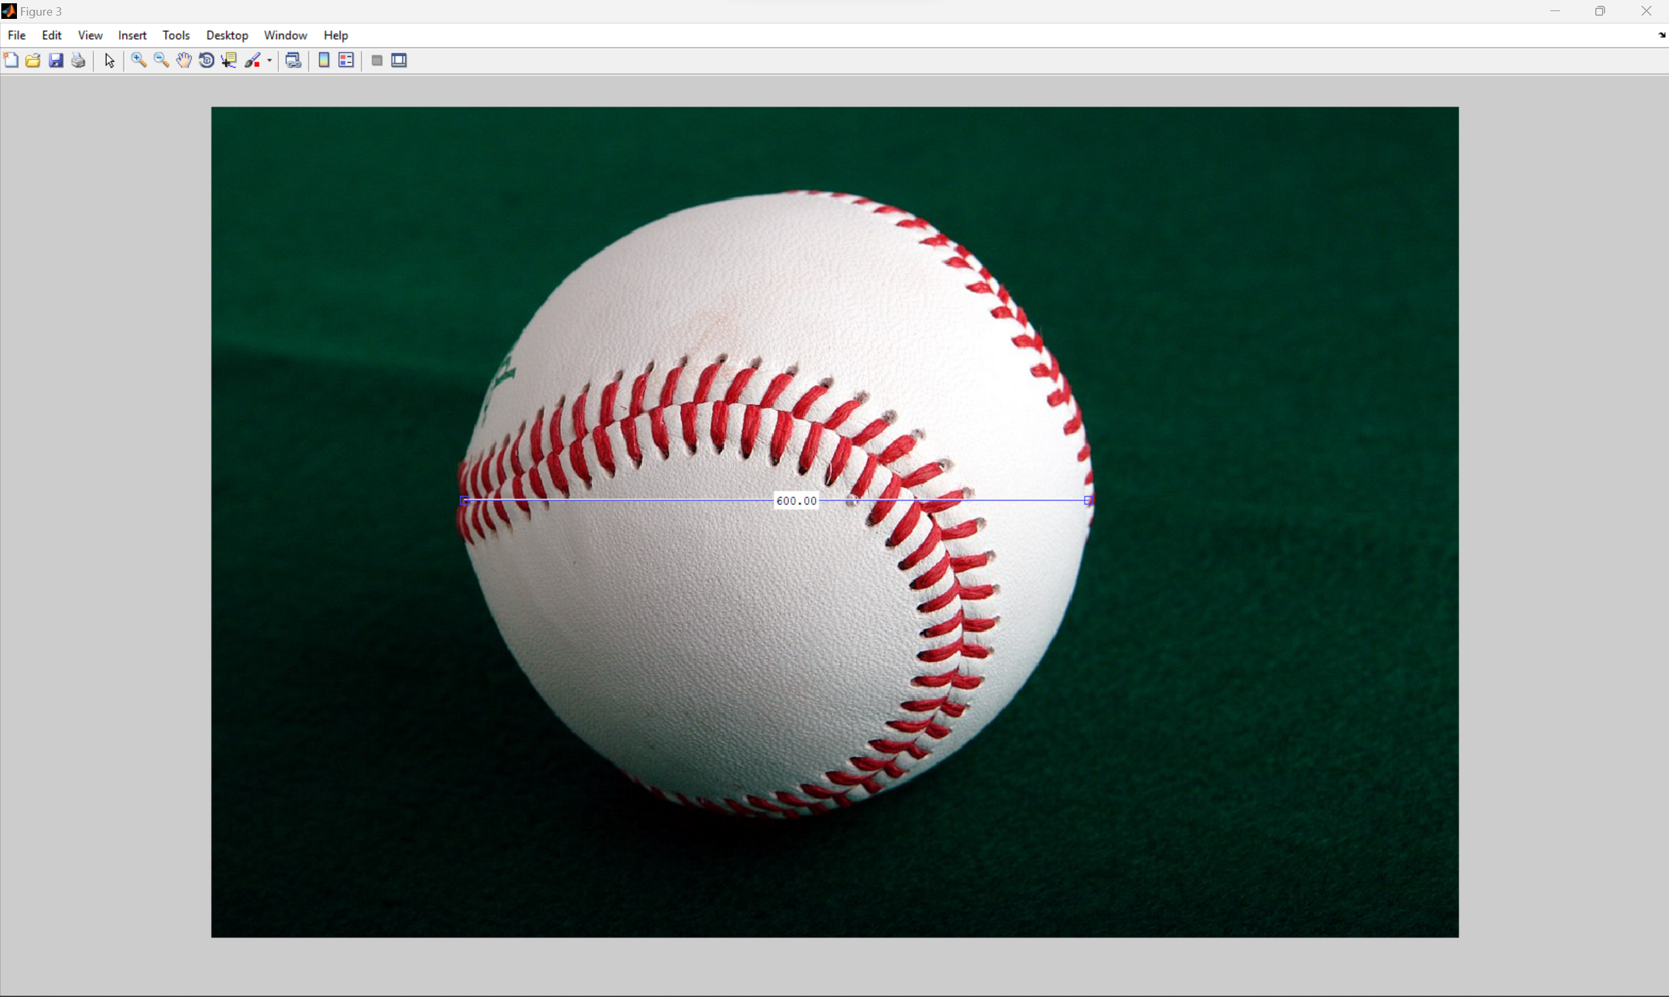

**Conclusion:**

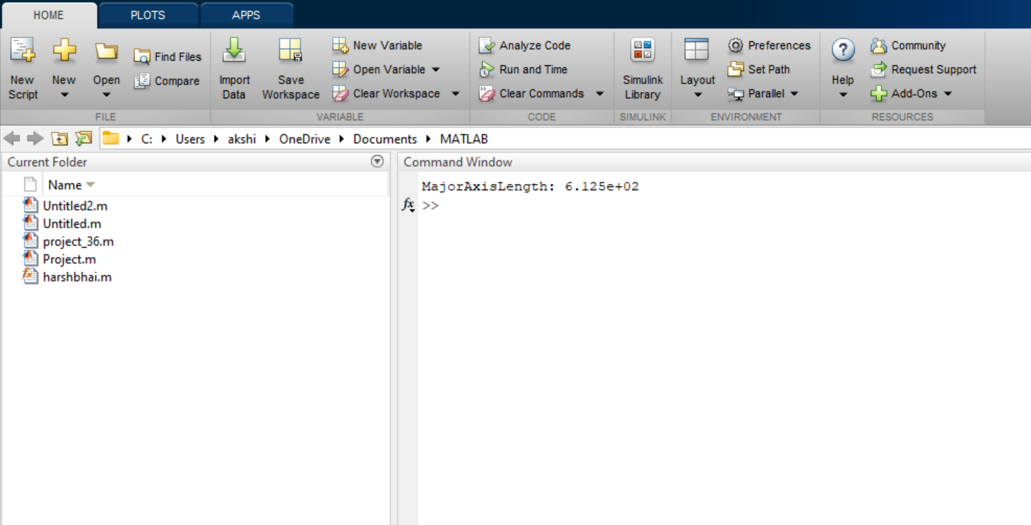

Hence, we get the desired length.